**Using Google Scholar**

The Library has enabled its full text holdings on WorldCat  (the Library's OpenURL linking service) in Google Scholar.  Search results display the following University of Unambia Library links in results, when configured correctly:

* FullText@UNAM – Links to a University of UNAM Library’s full text sources through WorldCat.

NOTE:  To enable your computer to find the relevant material on Google Scholar, you will have to make the following changes to your settings for Google Scholar when you are off-campus.  On campus users are recognized by their IP and no configuration should be needed.

Follow this link <https://scholar.google.co.za/scholar_settings?sciifh=1&hl=en&as_sdt=0,5#2> that will direct you to the settings screen for Google Scholar.

**Setting up Google Scholar**

* Go to **Google Scholar** search page.

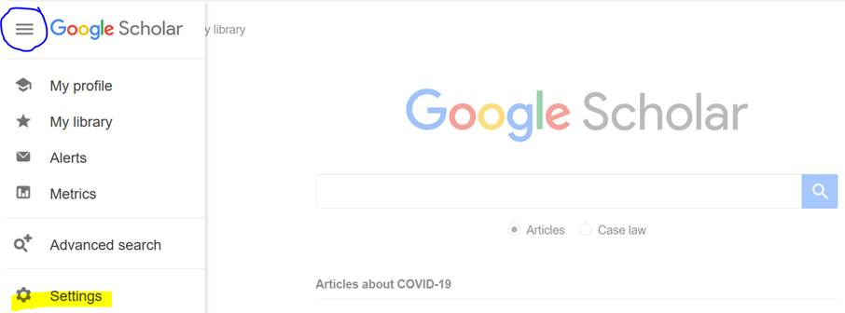

* Click on **the** menu button and then click **Settings**.
* Select **Library links** and search for University of Namibia.
* Search University of Namibia
* Mark boxes –Univ UNAM & WorldCat
* Save settings

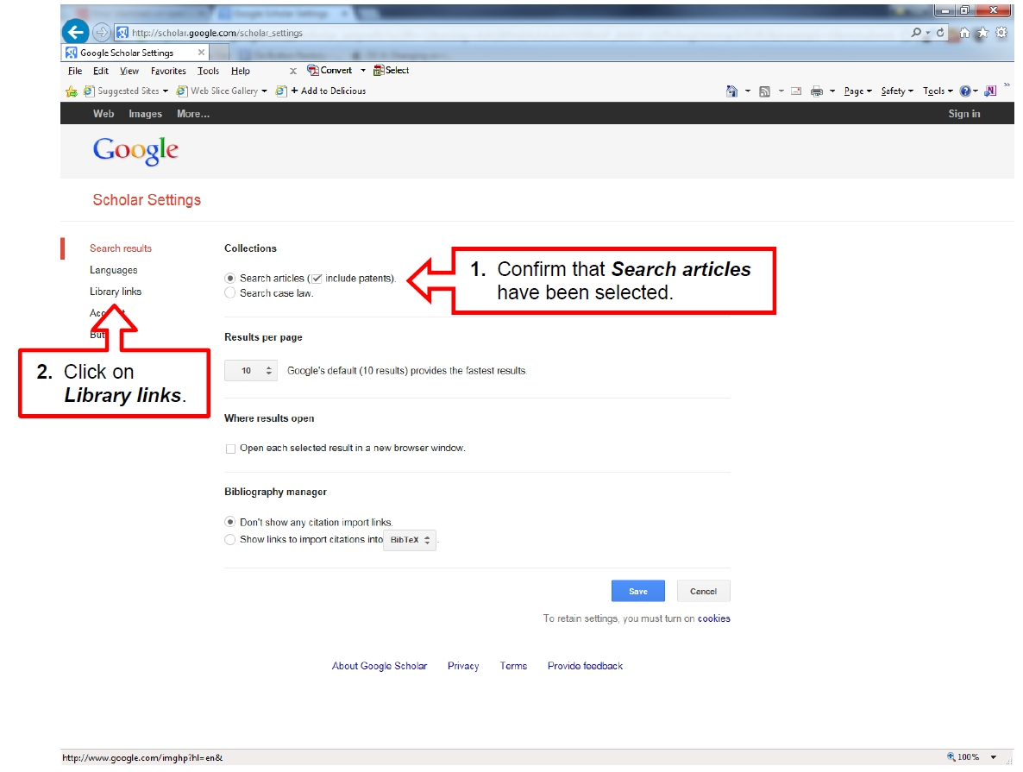

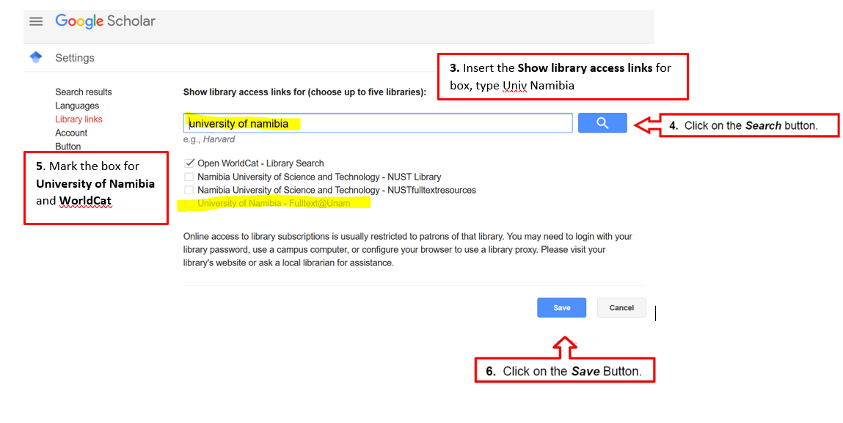

From your search results, choose the relevant links on the right-hand side, to view the full-text journal articles.

Please note that when accessing licensed library resources, from off-campus, users will be prompted to authenticate as library users.

